Core CDDs & Playbooks Supporting Trunk-Based Development + Sandbox Spawning
June 2nd 2025

📁 01. Governance
- 1- CDD Code & Infrastructure Governance
- 2- EVA Environment & Data Lifecycle Roadmap (2025–2027)

📁 02. Sandbox Deployment & Management
- 1- EVA Dev Sandbox Enablement Playbook
- 2- CDD SI Sandbox Enablement into two realistic paths

📁 03. Data & Lifecycle Strategy
- 1- CDD EVA Data & Environment Lifecycle

01-1. [CDD – Code & Infrastructure Governance]
01 - Gov - 01 CDD Code & Infrastructure Governance.docx
Role: Sets DevOps and Git policies for all EVA projects
- Enforces trunk-based development
- Requires merge back to shared codebase
- Mandates reusable Dev/Test/UAT IaC templates
- Defines gold-copy solution spaces
- Prevents silos and version drift across projects

01-2. [EVA Environment & Data Lifecycle Roadmap (2025–2027)]
01 Gov - 02 EVA Environment & Data Lifecycle Roadmap (2025–2027).docx
Role: Roadmap for progressive scaling of cloning, onboarding, and governance
- Phase 1–3: from manual cloning to GitOps automation to ephemeral self-serve
- Integrates cloning API, prompt promotion workflow, PII masking, sandbox registry

02-1 [EVA Dev Sandbox Enablement Playbook]
02 Sandbox - 01 EVA Dev Sandbox Enablement Playbook.docx
Role: Full lifecycle and technical playbook to spawn Dev/Test/UAT sandboxes
- Two paths: Quick & Dirty, Polished Kit
- Includes reference architecture, scripts, CI/CD integration, RBAC
- Contains onboarding flows, repo layout, audit rules

02-2 [CDD – SI Sandbox Enablement into Two Realistic Paths]
02 Sandbox - 02 CDD SI Sandbox Enablement into two realistic paths.docx
Role: Shows two deployment paths for onboarding SIs quickly and securely
- Matches EVA Playbook Quick & Dirty vs Polished Kit
- Practical for explaining onboarding to stakeholders
- Includes infra, RBAC, dataset loading, audit/TTL

03-1 [CDD – EVA Data & Environment Lifecycle Management]
03 Lifecycle - 01 CDD EVA Data & Environment Lifecycle.docx
Role: Provides repeatable lifecycle model for cloning and refreshing environments
- Decouples data from code
- Defines gold data vault and data tagging
- Supports project-specific overlays without code duplication
- Enables safe testing, RBAC tagging, prompt reuse

📌 CDD Mapping to End State Architecture Diagram
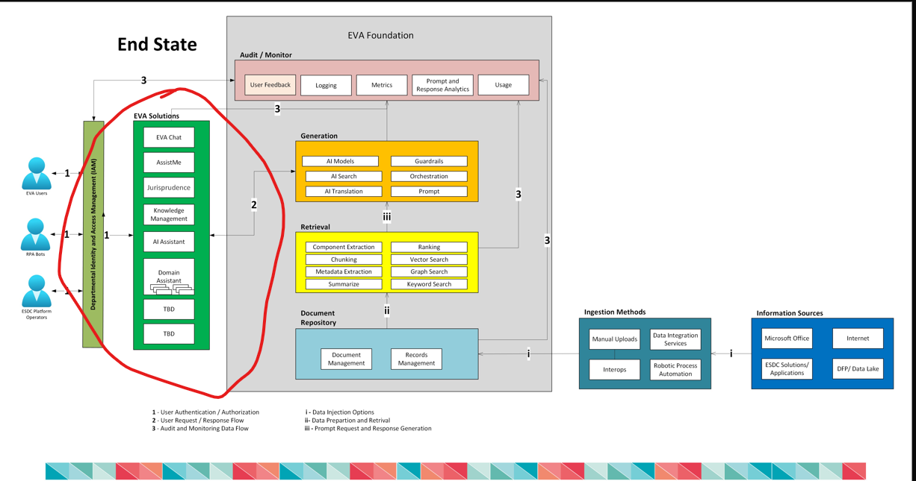

# | Architecture Element | Mapped File | Why It Applies
1 | Departmental Identity and Access Management (DIAM)User Authentication / Authorization | ✅ 02 Sandbox - 01 EVA Dev Sandbox Enablement Playbook.docx✅ 01 Gov - 01 CDD Code & Infrastructure Governance.docx | Enforces RBAC roles (e.g., SI_Admin, SI_Reader) per solution and sandbox; ensures Entra ID-based isolation and role consistency across deployments.
2 | EVA Solutions (AssistMe, Jurisprudence, KM, AI Assistant, etc.)— shared code, separate look & feel, data | ✅ 03 Lifecycle - 01 CDD EVA Data & Environment Lifecycle.docx✅ 01 Gov - 01 CDD Code & Infrastructure Governance.docx | Enables modular overlays per solution; allows code reuse with distinct prompts, datasets, and UI. Prevents drift by enforcing trunk-based contributions.
3 | Audit / Monitor (User Feedback, Logging, Metrics, Prompt Analytics) | ✅ 02 Sandbox - 01 EVA Dev Sandbox Enablement Playbook.docx✅ 01 Gov - 01 CDD Code & Infrastructure Governance.docx | Captures audit logs, telemetry, TTL management, and usage metrics per DA instance. Ensures monitoring boundaries for isolated environments.
i | Data Injection Options (Manual Uploads, RPA, Interops, etc.) | ✅ 03 Lifecycle - 01 CDD EVA Data & Environment Lifecycle.docx | Provides ingestion strategies per project (e.g., gold datasets, obfuscated test sets). Supports clean onboarding with safe, traceable document flows.
ii | Retrieval Logic (Chunking, Metadata Extraction, Vector Search, Graph Search) | ✅ 03 Lifecycle - 01 CDD EVA Data & Environment Lifecycle.docx✅ 02 Sandbox - 01 EVA Dev Sandbox Enablement Playbook.docx | Describes how RAG pipelines and embeddings can be reused with dataset-specific tagging and indexing per solution. Promotes standardization with flexibility.
iii | Prompt Request / Response Generation (LLMs, Orchestration, Translation, Guardrails) | ✅ 01 Gov - 01 CDD Code & Infrastructure Governance.docx✅ 03 Lifecycle - 01 CDD EVA Data & Environment Lifecycle.docx | Details prompt templates and orchestration across shared EVA services. Supports prompt sets per DA instance and controlled evolution via config-as-code.

✅ Summary
These five documents support all key architectural layers in the EVA Foundation End State:
📁 Governance
- 01 Gov - 01 CDD Code & Infrastructure Governance.docx
- 01 Gov - 02 EVA Environment & Data Lifecycle Roadmap (2025–2027).docx
📁 Sandbox Management
- 02 Sandbox - 01 EVA Dev Sandbox Enablement Playbook.docx
- 02 Sandbox - 02 CDD SI Sandbox Enablement into two realistic paths.docx
📁 Data & Lifecycle Strategy
- 03 Lifecycle - 01 CDD EVA Data & Environment Lifecycle.docx

